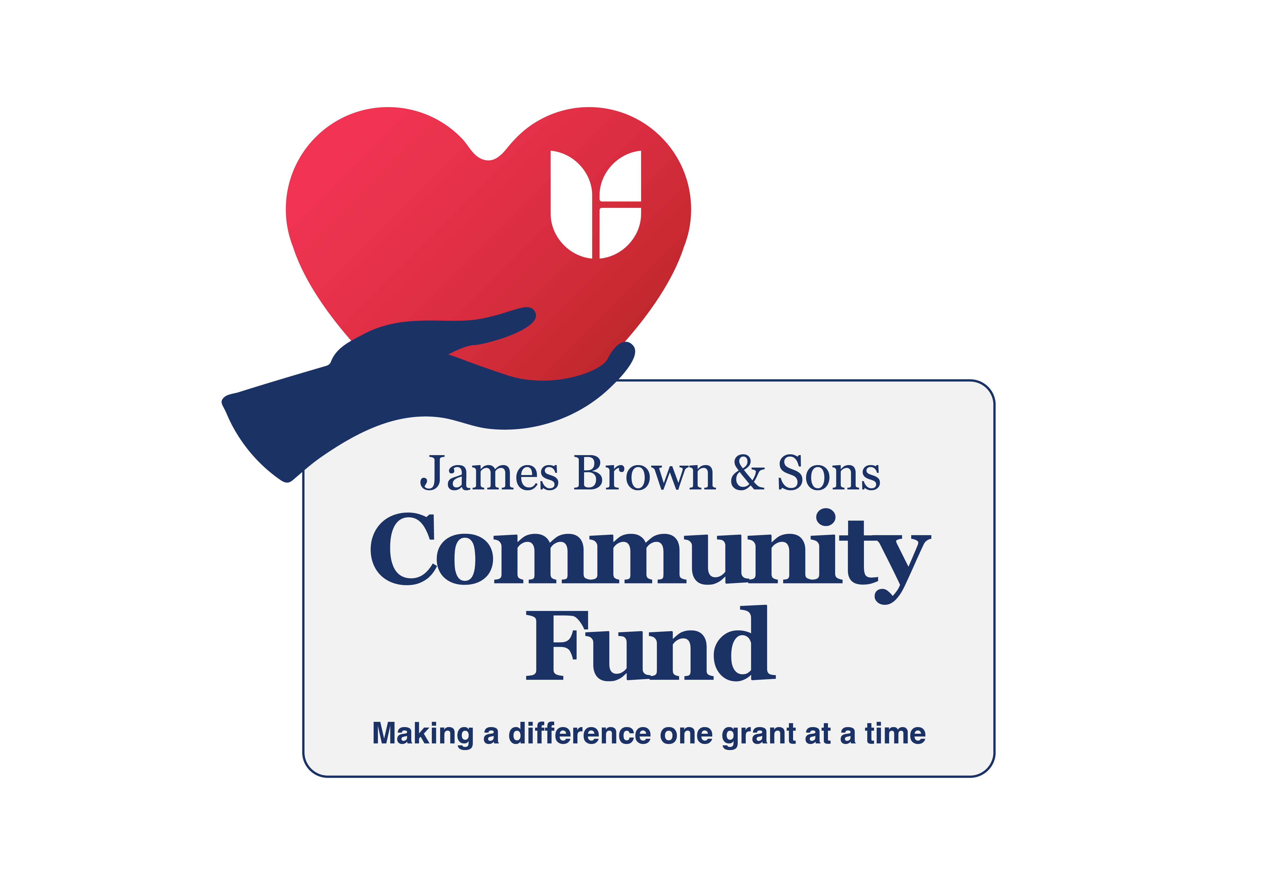
Application Form 2025
January 2025
Beverley Brown | [Date] | [Course title]

Name  The name of the organisation applying for funding. This must match with the information on your bank statements, governing documents etc. | Address  Address and postcode of the organisation applying for funding
Type of organisation  Constituted community group, Registered charity, Social enterprise, Community Interest Company (CICs) Limited by Guarantee - not CICs Limited by Shares, Faith based group | Charity Number if applicable
Name, email and telephone number of main contact  This should be a key person involved in your project. | Name, email and telephone number of alternative contact
Name of Project | Location of project, including postcode
Total cost of project | How much funding are you requesting?  The maximum amount of funding you can request is £2000 and the minimum is £1000.
Match funding  If some of the money for your project will come from other sources, tell us the total amount, where it will come from and when it needs to be spent by. Please note we will only process applications where any additional money required has been secured. | Project delivery period  Please let us know if your project has to happen at a specific time e.g., Easter. Please ensure the start date is realistic. Note of funding awarding dates can be found in the accompanying Guidance notes.
Nearest James Brown & Sons  Available at https://www.jamesbrownfuneraldirectors.com/locations the project must take place within a two-mile radius of a James Brown & Sons location. | How and by when will it be spent?  You must provide an itemised breakdown of how you intend to spend your grant should you be successful. General headings e.g. materials are not acceptable
Project summary and benefit to local community
Max 500 words. A clear and persuasive description of a well-researched project. Include information about the need and demand for your project, how your project meets the need you have identified and an estimate of the number of people the project will support. Tell us what your project will be doing and provide information that will help us reach a decision on shortlisting and funding. Tell us the overall aim and how it will improve your local community.

Privacy policy
In this section of the application form we’re asking you to read some important information about our data protection responsibilities. It’s important you understand how we will use and store the information you give us. You need to know what to do if you believe any of your information is commercially sensitive or confidential. We ask you to sign the application form to confirm you have read and understood the Privacy Information, know your rights and how your data will be used. Please do not provide us with personal data about others unless there is a need to know this as part of your application e.g., name of applicant. We will handle any personal data you do provide us in line with data protection obligations. For a copy of our privacy policy, please refer to https://www.funeralpartners.co.uk/privacy-policy/
I confirm I have read and understood the above
Signature
Date
Details of any conflict of interest
In this section, please give us brief details of any conflict of interest you may have. For example, if you are involved in a business which provides goods or services to the project if it is funded. A conflict of interest is any situation in which an applicant, or the applicant’s organisation, has a personal connection with, or a business interest in any organisation or individual that will be paid to deliver the project. Conflicts of interest or potential conflicts of interest must be declared before any grant funding is awarded. Failure to disclose conflicts of interest may result in the withdrawal of funding and the repayment of the grant. James Brown & Sons and Funeral Partners want to make sure that any conflict of interest associated with fund applications is declared, so that any conflict can be appropriately managed. Please declare to us any conflict of interest you may have in relation to your application for funding.
Signature
Date
Mandatory Requirements
- Demonstrate that the proposal is in response to identified community need;
- Have a minimum of 3 unrelated Trustees/Directors/Management Committee members;
- Have a Governing Document, i.e. a constitution or Memorandum & Articles;
- Have a Bank Account in the name of the group, with at least 2 unrelated signatories
- Have Annual Accounts, or for smaller groups, an Income and Expenditure Sheet for the most recent financial period.
- Have a Safeguarding Policy if working with young people under the age of 18, and/or working with vulnerable adults;
- Groups will also need to have AccessNI checks in place where required and have the relevant insurance in place, including public liability (if required) before delivering activities.

I confirm we have met the mandatory requirements.

If the application for funding is successful these must be sent to Funeral Partners, by email before the funding will be awarded. Funding awards will be withdrawn if the mandatory requirements are not met.

Signature
Date
How did you hear about the James Brown & Sons Community Fund
Attending promotional events
Please confirm you are happy to participate and cooperate for promotional events and activity in relation to advertising and promoting the community fund and awards
I am happy to participate on behalf of my organisation
Signature
Date
Please note we will carry out follow up visits as part of our monitoring process.

