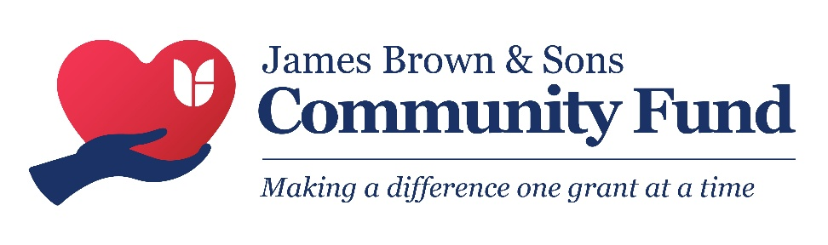

James Brown & Sons – Spark Awards Application Guide

General Information

About the James Brown & Sons Community Fund
In these challenging economic times, we have established the James Brown & Sons Community Fund to help fund good causes provided by local charities and not‑for‑profit organisations working for the benefit of people who live within 2 miles of an area in which James Brown & Sons Funeral Directors operate. Businesses, individuals and ‘for profit’ organisations are not eligible.
The Community Fund will be a rolling programme during 2026. Applications can be submitted at any time during the application window (see https://www.jamesbrownfuneraldirectors.com/ for details) and will be considered on the next available judging date. Applicants will typically be informed of the outcome within one month of the application window closing.
Organisations can request the total cost of the project or a contribution of up to £1250. We aim to fund projects that run for 3 months or longer, but we may consider shorter projects if ongoing community benefits can be demonstrated.

Funding Focus
Grants are available to support local activities that improve quality of life and align with one or more of the following categories:
- Health
- Education
- Employment opportunities
- Poverty / Social Deprivation

Priority will be given to:
- Projects addressing the needs of the most disadvantaged in the local community
- Projects led by people with a strong understanding of community needs and strong community connections

Examples of Eligible Projects
- Health and wellbeing activities for older people (e.g., exercise classes)
- Literacy or numeracy clubs
- Specialist mental health support for young people
- Kitchen equipment for youth holiday clubs
- Support for community centres starting a lunch club
- Healthy eating projects for families
- Projects that promote community engagement and volunteering

Examples of Ineligible Projects – these are examples only and the list is not exhaustive
- Work already completed
- Office furniture/equipment requests (e.g., desks, racking)
- Applications for vouchers
- Political donations or promotion
- Fundraising activities or challenges
- Running costs or overheads
- Activities collecting funds for redistribution
- Overseas appeals
- Marketing promotions
- Research projects
- Activities the state has a legal obligation to provide
- Defibrillators

Application Process

Grant Amounts
Applications for grants must be between £750 and £1250.

How to Apply
Applications must be submitted using the official application form available at:
- https://www.jamesbrownfuneraldirectors.com
- Or by emailing jamesbrowncommunityfund@funeralpartners.com
Submit completed applications by email by the relevant closing date. You will receive confirmation of receipt.

Supporting Documents Required (if application is successful)
- Minimum of 3 unrelated Trustees/Directors/Management Committee members;
- Governing Document, i.e. a constitution or Memorandum & Articles;
- Bank Account in the name of the group, with at least 2 unrelated signatories
- Annual Accounts, or for smaller groups, an Income and Expenditure Sheet for the most recent financial period.
- Relevant equality legislation and requirements
- Safeguarding Policy if working with young people under the age of 18, and/or working with vulnerable adults;
- Groups will also need to have AccessNI checks in place where required and have the relevant insurance in place, including public liability (if required) before delivering activities.

Application Windows
- Please see https://www.jamesbrownfuneraldirectors.com for details

Applicants must download the latest guide and application form prior to applying.

Eligibility Criteria
Eligible not‑for‑profit organisations include:
- Constituted community groups
- Registered charities
- Social enterprises
- CICs Limited by Guarantee (not CICs Limited by Shares)
- Faith‑based groups
We particularly welcome applications from small, local charities embedded in their communities. National charities may apply where strong local connections can be demonstrated.
- For full Terms and Conditions please visit https://www.jamesbrownfuneraldirectors.com

